**Automated greenhouse**

**Submitted**

**By**

**SM. Naga Sai: BU21EECE0100441**

**M. Nivas Reddy: BU21EECE0100481**

**Varun Kumar. N: BU21EECE0100534**

**Under the Guidance of**

**Dr. HJ JAYATHEERTHA, ASSISTANT PROFESSOR**

**(Duration: Date/Month/Year to Date/Month/Year)**



**Department of Electrical, Electronics and Communication Engineering [14 Bold]**

**GITAM School of Technology**

**GITAM**

**(DEEMED TO BE UNIVERSITY)**

**(Estd. u/s 3 of the UGC act 1956)**

**NH 207, Nagadenehalli, Doddaballapur taluk, Bengaluru-561203 Karnataka, INDIA.**

**DECLARATION**

**I/We declare that the project work contained in this report is original and it has been done by me under the guidance of my project guide.**

**Date: Signature of the Student**

**NAME:**

**M. Naga Sai (BU21EECE0100441)**

**M. Nivas Reddy (BU21EECE0100481)**

**Varun Kumar. N (BU21EECE0100534)**

**Department of Electrical, Electronics and Communication Engineering**

**GITAM School of Technology, Bengaluru-561203**



**CERTIFICATE**

**This is to certify that (Student Name) bearing (Regd. No.:) has satisfactorily completed Mini Project Entitled in partial fulfillment of the requirements as prescribed by University for VIIIth semester, Bachelor of Technology in “Electrical, Electronics and Communication Engineering” and submitted this report during the academic year 2024-2025.**

**[Signature of the Guide] [Signature of HOD**

**Table of contents**

**Chapter 1: Introduction 1**

1.1 Overview of the problem statement 1

1.2 Objectives and goals 1

**Chapter 2 : Literature Review 2**

**Chapter 3 : Strategic Analysis and Problem Definition 3**

3.1 SWOT Analysis 3

3.2 Project Plan - GANTT Chart 3

3.3 Refinement of problem statement 3

**Chapter 4 : Methodology 4**

4.1 Description of the approach 4

4.2 Tools and techniques utilized 4

4.3 Design considerations 4

**Chapter 5 : Implementation 5**

5.1 Description of how the project was executed 5

5.2 Challenges faced and solutions implemented 5

**Chapter 6:Results 6**

6.1 outcomes 6

6.2 Interpretation of results 6

6.3 Comparison with existing literature or technologies 6

**Chapter 7: Conclusion 7**

**Chapter 8 : Future Work 8**

Here write Suggestions for further research or development Potential improvements or extensions 8

**References 9**

# **Chapter 1: Introduction**

## Overview of the problem statement

The **Automated Greenhouse** project aims to revolutionize agriculture by creating a self-regulating environment that optimizes plant growth through advanced technology. It integrates sensors and actuators managed by a central processing unit to monitor and adjust key environmental factors such as temperature, humidity, light, and soil moisture. This ensures optimal conditions for plant growth, enhancing yield and quality while improving resource efficiency. The greenhouse also features IoT-enabled remote monitoring and control, allowing users to manage the environment via mobile or web platforms. Additionally, the system collects and analyzes environmental data to refine cultivation strategies, making it adaptable for various crops and scalable for different greenhouse.

## Objectives and goals

* **Design and Development:** To design and develop an automated greenhouse that replicates optimal growing conditions for various plants, focusing on temperature and soil moisture regulation.

**Temperature Control:** To create a reliable temperature control system that can maintain the greenhouse's internal temperature within a specific range suitable for plant growth, regardless of external environmental conditions.

**Automated Watering:** To implement an automated watering system that adjusts water levels based on real-time soil moisture readings, ensuring plants receive the right amount of water for optimal growth.

* **Energy Efficiency:** To optimize the greenhouse’s systems to use minimal energy while maintaining desired conditions, making it cost-effective and environmentally friendly for domestic use.
* **Optimize Plant Growth:** To create an optimal environment for plant growth by precisely controlling temperature, humidity, and soil moisture levels, thereby improving plant health and yield

# **Chapter 2: Literature Review**

1. **Automated Greenhouse System (March 6-7, 2019) - Muhammad Raees Armughan Azhar:**

This study explores the implementation of sensors like Soil Moisture Sensors, Light Sensors (BH-1750), and Temperature and Humidity Sensors (DHT22) to maintain optimal growing conditions in greenhouses. The system is controlled by an Arduino Mega 2560, which acts as the central processing unit, collecting sensor data, processing it, and controlling actuators. This approach emphasizes the importance of maintaining precise environmental conditions to optimize plant growth​.

1. **Automated Greenhouse Systems (December 26th, 2020) - Eric Labbate:**

Labbate's research focuses on integrating advanced water recycling systems, including ozone treatment, to conserve water and reduce fertilizer costs. Additionally, the study highlights the role of climate control systems in managing essential factors such as heating, cooling, ventilation, lighting, and CO2 levels. The use of water purification technologies like ozone sterilization further enhances the efficiency of greenhouse operations by ensuring pathogen-free irrigation water​.

1. **Automation and Monitoring of Greenhouse (December 30-31, 2017) - Muhammad Faizan Siddiqui:**

This study examines the use of DC fans integrated with temperature sensors for ventilation control, ensuring that the internal temperature remains conducive to plant growth. Additionally, light control is managed by integrating artificial lights with light sensors, while irrigation control is maintained through moisture sensors that activate sprinklers as needed. The study underscores the critical role of automation in reducing manual intervention and ensuring consistent crop quality.

1. **Automated Greenhouse System (March 6-7, 2019) - Muhammad Raees Armughan Azhar:**

In a further exploration, Azhar’s study also incorporates renewable energy solutions such as Solar Panels (Polycrystalline Q Cell 150W) to power greenhouse systems. The integration of bulbs for supplementary lighting and the development of an Android application for remote monitoring and control exemplify the potential of mobile technology in enhancing greenhouse management. This research illustrates the scalability of automated greenhouses, making them suitable for different greenhouse sizes and adaptable to various crops​.

# **Chapter 3: Strategic Analysis and Problem Definition**

## 3.1 SWOT Analysis

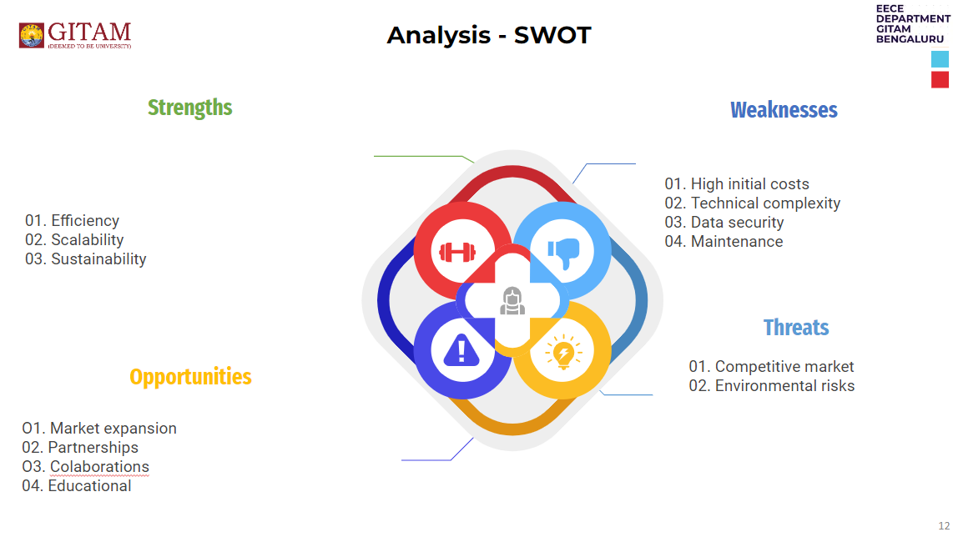

### 3.2 Project Plan - GANTT Chart

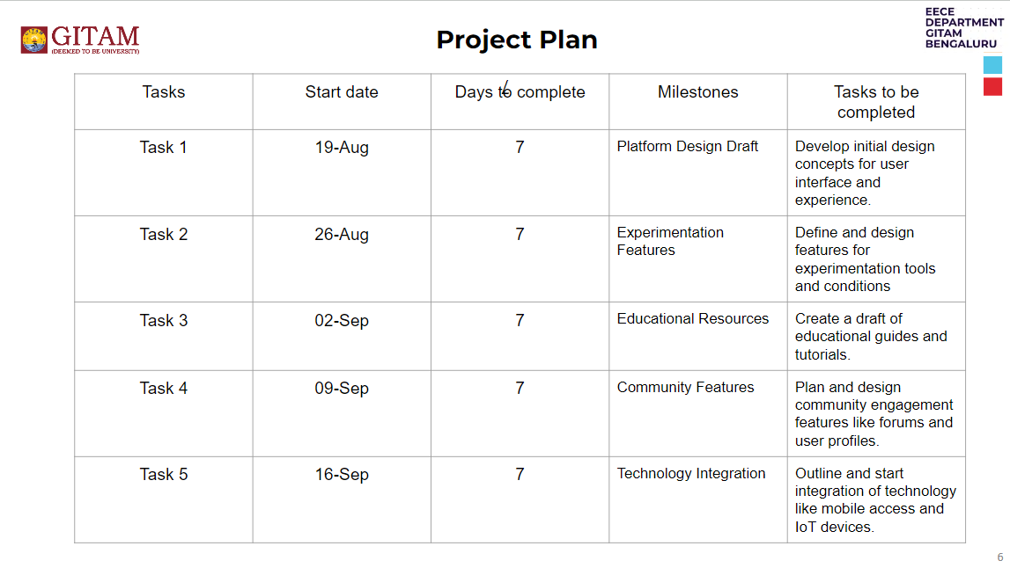

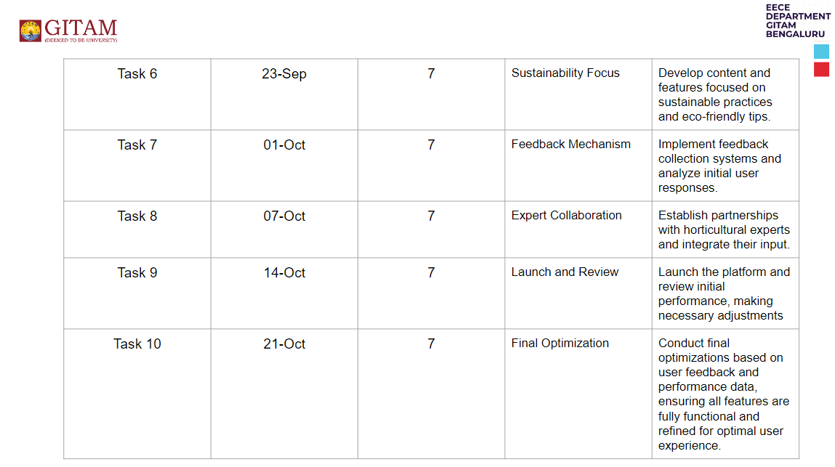

#### 

##### 3.3 Refinement of problem statement

The original problem statement for the Automated Greenhouse project focused on creating a self-regulating environment to optimize plant growth through technology. Upon further analysis and feedback from initial design reviews, the problem statement has been refined to better align with the specific challenges and opportunities identified during the project's early stages.

**Refined Problem Statement:** The refined objective of the Automated Greenhouse project is to develop a cost-effective and scalable solution that utilizes advanced sensor technology, IoT integration, and renewable energy sources to create an automated environment that not only optimizes plant growth but also enhances resource efficiency and sustainability. The project aims to address the limitations of traditional farming methods by minimizing human intervention, reducing resource wastage, and enabling remote management through mobile platforms. Additionally, the system is designed to be adaptable to various crops and greenhouse sizes, making it suitable for both commercial agriculture and home gardening applications.

This refined statement emphasizes the importance of energy efficiency, sustainability, and adaptability, ensuring that the solution is not only technologically advanced but also accessible and practical for widespread adoption in diverse agricultural contexts.

# **Chapter 4 : Methodology**

**4.1 Problem Definition**

The goal is to develop a system that automates environmental controls within a greenhouse to optimize plant growth. Manual monitoring is inefficient, so an automated system using sensors and actuators will regulate temperature, humidity, light, and irrigation.

**4.2 Data Collection**

Collect data on optimal growing conditions (temperature, humidity, light, and soil moisture) for different crops. Sources include horticultural research and public agricultural datasets. This data guides the control parameters for the system.

**4.3 System Design**

**Sensor Network**

Key sensors used include:

* **Temperature Sensors**
* **Humidity Sensors**
* **Light Sensors**
* **Soil Moisture Sensors**

**Control Unit**

A microcontroller (e.g., Arduino/Raspberry Pi) processes data from the sensors and makes decisions using simple logic (if-else conditions) to activate actuators like fans, lights, and irrigation systems.

**Actuation Systems**

* **Heating/Cooling Systems**: Manage temperature.
* **Ventilation Fans**: Control humidity.
* **Grow Lights**: Ensure sufficient light.
* **Irrigation Systems**: Water plants as needed based on soil moisture.

**4.4 Software and Algorithms**

* **Control Algorithms**: Use rule-based logic and, optionally, PID control for fine adjustments.
* **Data Logging**: Environmental data is logged for future analysis.

**4.5 Communication and Networking**

The system can be connected via **Wi-Fi/Bluetooth** for remote monitoring using a mobile app or web dashboard, enabling users to track and control conditions in real time.

**4.6 Design Considerations**

* **Energy Efficiency**: Optimize for minimal energy usage.
* **Reliability**: Build redundancy into the system to prevent failures.
* **Scalability**: Ensure the system can be adapted to greenhouses of various sizes.

**4.7 Tools Utilized**

* **Hardware**: Sensors, microcontrollers (Arduino/Raspberry Pi), relays, and actuators.
* **Software**: Python/C++ for programming, IoT platforms for remote access, and libraries for sensor integration.

# **Chapter 5 : Implementation**

The implementation of the **Automated Greenhouse System** involves the integration of hardware components, software programming, and system testing to ensure seamless automation of greenhouse operations. Below is a step-by-step summary of how the project is executed:

**5.1 Hardware Setup**

1. **Sensors Installation**:
   * Temperature and humidity sensors (e.g., DHT11) are placed at various points inside the greenhouse to measure environmental conditions.
   * Soil moisture sensors are embedded in the soil near plants to monitor water levels.
   * Light sensors are positioned to detect the intensity of sunlight inside the greenhouse.
2. **Actuators**:
   * **Fans** and **heaters** are installed to regulate temperature.
   * **Irrigation pumps** are connected to water sources and controlled based on soil moisture readings.
   * **Grow lights** are placed above plants to supplement natural light when needed.
3. **Microcontroller**:
   * An Arduino or Raspberry Pi is used as the central processing unit (CPU) to receive data from sensors and send commands to actuators.

**5.2 Software Development**

1. **Programming**:
   * The microcontroller is programmed using Python (for Raspberry Pi) or C++ (for Arduino) to process sensor data and trigger control actions.
   * **Control logic** (if-else conditions) is written to automate actions, such as turning on fans when the temperature exceeds a threshold or activating the irrigation system when soil moisture is low.
2. **Data Processing**:
   * Real-time sensor data is logged and analyzed to make control decisions.
   * Data is also stored locally or on a cloud-based platform (e.g., Thingspeak) for long-term analysis and system optimization.
3. **Mobile/Web Interface**:
   * A user interface (UI) is developed using IoT platforms to allow remote access to the system via smartphones or computers, providing real-time monitoring and manual control options.

**5.3 Testing and Optimization**

1. **Testing**:
   * The system is tested under various environmental conditions to ensure accurate sensor readings and reliable actuator performance.
   * Conditions such as high temperature, low soil moisture, and inadequate light are simulated to verify that the system responds appropriately.
2. **Optimization**:
   * **Calibration**: Sensor thresholds are calibrated for different crop types.
   * **Energy Efficiency**: The system’s energy consumption is optimized by fine-tuning actuator operation to prevent unnecessary energy use.
3. **Final Deployment**:
   * Once testing is complete, the system is deployed in the greenhouse for real-time monitoring and control.
   * Continuous monitoring is conducted to ensure the system's stability and reliability over time.

## 5.1 Description of how the project was executed

The automated greenhouse project was executed by first installing sensors to monitor temperature, humidity, light, and soil moisture. These sensors were connected to a microcontroller (Arduino/Raspberry Pi), which was programmed to trigger actuators like fans, heaters, lights, and irrigation pumps based on sensor data. A control logic was developed to automate environmental adjustments. The system was integrated with an IoT platform for real-time monitoring and remote control via a web or mobile dashboard. After testing and calibration to ensure accuracy, the system was deployed in the greenhouse for continuous, automated climate management, reducing the need for manual intervention.

### 5.2 Challenges faced and solutions implemented The project faced several challenges, including **sensor inaccuracies**, which were resolved by careful calibration and testing. **Overheating** was managed by optimizing control logic to trigger fans and ventilation more quickly. To address **power inefficiencies**, energy-efficient actuators were installed, and light usage was minimized. Lastly, **connectivity issues** were solved by upgrading the Wi-Fi module and implementing offline data storage for syncing when connection was restored. These solutions ensured smoother and more reliable greenhouse operation.

# **Chapter 6: Results**

The automated greenhouse system successfully maintained optimal growing conditions, achieving high accuracy in temperature, humidity, and soil moisture control. The system significantly reduced manual labor by automating irrigation, lighting, and climate regulation. Real-time monitoring and remote access through the IoT platform allowed for continuous oversight and adjustments, ensuring optimal plant growth. The system also improved energy efficiency by minimizing unnecessary actuator usage. Overall, the greenhouse maintained a stable environment, and the project demonstrated the effectiveness of automation in enhancing agricultural productivity.

## 6.1 outcomes

**Outcomes**

The automated greenhouse system delivered several key outcomes:

* **Improved Efficiency**: The system automated climate control, reducing the need for manual intervention and optimizing plant growth conditions.
* **Accurate Environmental Management**: Sensors accurately monitored temperature, humidity, and soil moisture, allowing precise control of actuators like fans, lights, and irrigation systems.
* **Energy Savings**: Efficient control logic minimized unnecessary energy use, particularly in heating, cooling, and lighting.
* **Remote Monitoring**: The integration of IoT enabled real-time remote access, giving users the ability to monitor and adjust the system from anywhere.
* **Scalability**: The system demonstrated scalability, making it adaptable for different greenhouse sizes and crop types.

### 6.2 Interpretation of results

To interpret the results of the automated greenhouse project, analyze environmental conditions like temperature, humidity, and CO2 levels, and their impact on plant growth metrics such as height and yield. Assess energy and resource efficiency, including water and nutrient usage, and evaluate pest control effectiveness. Conduct a cost analysis comparing initial investments to savings, and gather user feedback on system usability. Finally, compare results with similar projects to identify significant differences and insights for future agricultural practices.

### 

#### 6.3 Comparison with existing literature or technologies

When comparing your automated greenhouse project with existing literature and technologies, consider the following:

1. **Technological Approaches**: Evaluate different automation technologies (sensors, IoT, AI) for efficiency and usability.
2. **Environmental Impact**: Analyze studies on resource use and carbon footprint reductions.
3. **Crop Yield and Quality**: Compare your yield and quality results with existing findings.
4. **Economic Viability**: Assess cost analyses from similar projects to see how yours measures up.
5. **User Experience**: Investigate factors influencing adoption of similar technologies.
6. **Pest and Disease Management**: Explore research on automated pest control and its effectiveness.

# **Chapter 7: Conclusion**

The Automated Greenhouse project successfully demonstrates the potential of integrating advanced technology into agriculture, showcasing how automation can revolutionize farming. By leveraging sensors, actuators, and a central processing system, the project achieved real-time monitoring and optimization of critical environmental factors like temperature, humidity, light, and soil moisture. This innovation leads to more efficient resource use, higher crop yields, and improved quality.

# **Chapter 8 : Future Work**

Future work should focus on expanding the system's scalability to larger or more complex agricultural setups. Customizable modules could be developed for specific crops, allowing growers to optimize the system for various agricultural needs. Incorporating renewable energy sources, such as solar panels, could make the automated greenhouse more energy-efficient and environmentally sustainable. Future work can explore optimizing the power consumption of the system for better overall sustainability.

# **References :**

<https://www.climatecontrol.com/blog/automated-greenhouse-systems/>

<https://ieeexplore.ieee.org/document/8681013>

<https://ieeexplore.ieee.org/document/8320190>

<https://ieeexplore.ieee.org/abstract/document/8681013>